KiloTech Scale (3 kg)

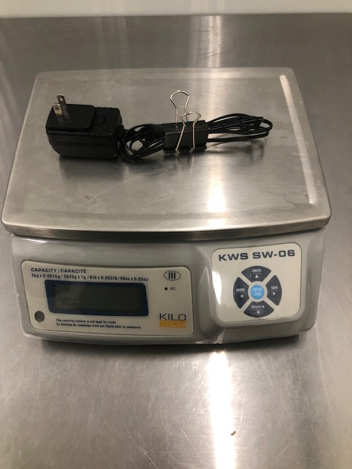
Scale is in excellent used condition, and is available now. The original purchase price was $313.59
Now accepting offers.

TELME EvoPasto 60 Automatic Batch Pasteurizer

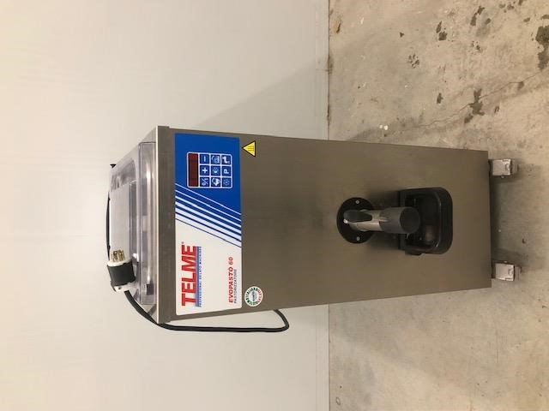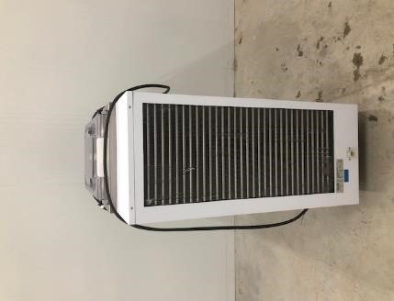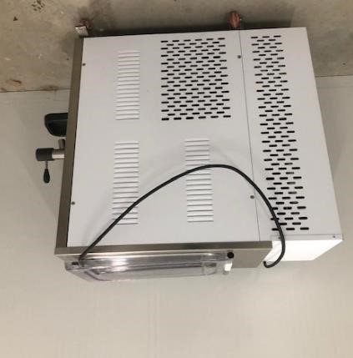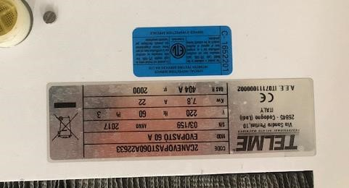

This professional pasteurizer is in like-new condition, and can be used in pasteurizing mixes for gelato and ice cream, and for hot-processing of syrups for sorbetto.
Original Purchase Price: $24,195
Now accepting offers.

